**Personal Project (2015-2016)**

**Unmanned Ground Vehicle**

**Supervisor: omitted**

**Word Count: 3499**

**Date: 6/12/2016**

**Table of contents**

Investigating…………………………………………...…………………Page 3

Planning………………………………………………………………… Page 7

Taking Action……………………………………………………………. Page 9

Reflecting………………………………………………………………. Page 13

Works Cited…………………………………………………………… Page 16

Appendix A…………………………………………………………….. Page 17

Appendix B………………………………………………………………….. Page 18

Appendix C…………………………………………………………………. Page 19

Appendix D…………………………………………………………………... Page 20

Appendix E…………………………………………………………………….. Page 21

Appendix F………………………………………………………………………. Page 22

Appendix G………………………………………………………………………. Page 23

Appendix H……………………………………………………………………… Page 24

Appendix I……………………………………………………………………….. Page 25

Appendix J………………………………………………………………………….. Page 26

**Investigating:**

The inspiration behind this project is my fascination with automobiles, as well as the technology, science, and engineering used in them. Application of engineering has dominated many industries. High tech companies like Tesla have conducted more research into the science behind their cars, and the aspect of programming and electrical circuits. My interest in this field has led to brainstorming a few ideas related to improving cars. However, these ideas were soon rendered too difficult as they needed incredibly high amounts of technical experience and a university level education. So I continued research until I came across the idea of creating a smartphone controlled ground vehicle. This topic is of interest to me as it combines the elements of product design, automobile systems, physics and programming. Therefore, the completion of this project will help me enhance my programming skills and increase my engineering experience. Creating a custom product is certainly a motivator for the product, so one can say that I am my own target market.

My goal is to enhance my design skills in addition to acquiring new set of skills in programming by designing and building a ground vehicle controlled by a smartphone. The school subjects related to my project are mathematics, which helps me map out the dimensions of my product with some calculation. Design which helps me create measurable success criteria, draw desigs and implement methods of testing. Finally, physics me translate the concepts of motion, forces, power and electricity.

I applied prior knowledge of vehicle mechanics I have of cars and used it to create a scaled down version of the cars. The product chosen may come with some challenges. However, by addressing the “challenges”, these will help developing my schools even further. The largest challenge will be overcoming the lack of experience in applying programming knowledge to the product and perfecting the circuitry needed.

My global context is Scientific and Technical Innovation. My exploration is modernization, industrialization and engineering. The project serves as a way to teach myself the basics of engineering. The topic of choice heavily relates to this global context as design elements and engineering of vehicles are consistently modernized. It will allow me to contribute something to society and will teach me about taking risks. The scientific and technical innovation also comes in, through adapting and working with what is available and learning how to use it to create a product that can address a need.

The first step to achieve the goal was to conduct research. Upon learning from a friend about the existence of a tech academy, called Kahrbni, which specializes in unmanned vehicles, drones, and mechatronics, I headed to their Facebook page to book an appointment with its founder by the name of Emad Al Omari. The academy aimed to fill the gap between theoretical knowledge and practical skills for young electrical engineering students in Jordan. I asked Emad, the Mechatronics Engineer, about materials, language and functions for programming, design features and the best way to build the car. I have consistently asked Emad about his background, achievements, especially as he is a mechatronics graduate and co-founded kahrbni (Appendix A).

I proceeded with Emad’s suggestions on what to research, which included electric currents, electricity concepts, and the Arduino platform” (Appendix ). This platform is an open source available to everyone for free use, has accessible hardware like microcontrollers, and is a good starter language. Emad’s information gave an overview of what needs to be done and what needs to be avoided while also acting as a “bridge” to explore into other beneficial research topics. The information placed on Arduino’s website is created by the employees of the company. It contains tutorials and is updated on a daily basis. It is not entirely objective, as it is a company that promotes its products and language as one that is simple and easy to learn. It is an excellent source as it is a quick guide on programming, understanding the variety of codes available and determining the most suitable microcontrollers.

The *IGSCE Physics* book is published in 2009 by Hodder Education. Cambridge endorses them and heavily uses their published books. It is fully objective as the content is based on scientific explanations. As an excellent source, it was essential for understanding circuits and applying it in my creation of the product.

*Programming Arduino TM Getting Started with Sketches* by Simon Monk is a source published by McGraw Hill Education. The book focuses on programming and electronics. Monk explained that electronics is his hobby, and he familiarized himself with programming. He is also author of *30 Arduino Projects for the Evil Genius* and *15 Dangerously Mad Projects for the Evil Genius* and has a website explaining these books. Simon bases most of his content on technical guides filled with details and illustrations. His content is factual, while also summarizing important codes and concepts at the end of every section. The book teaches one how to program using Arduino C, but Monk does not explain all the aspects of programming. Regardless it was a great start to understand a complex language.

*DC motor how it works* is an online article containing an animated video published by unnamed authors, but are a division of three people from a larger consulting engineer company known as Imajey Consulting Engineers (Pvt Ltd), with the director, Mathew Sabin supervising the content posted. They are reputable and well-known through a moderate 437,000 subscriber count on YouTube. It was based on the engineers’ knowledge of the topics, and it is non-biased due to it solely containing explanations on the fundamentals of a DC motor. The source’s flaw is that it does not cover all aspects such as the motor’s implementation into circuits. However, it does provide information that relate directly to programming, as it can show what aspects of the motor can be programmed like the spinning direction. It also highlights an inverse relationship between torque and speed, which is needed to formulate the success criteria and embed the motors into the circuit.

**Planning:**

Most of the specifications for a product such as a smartphone controlled RC car are heavily technical, and should mostly be about finding ways to create a product suitable to meeting my goals. The more specific success criteria points I create, the more work needs to be done in meeting the success criteria. The more points that are met, the more successful the product is. Therefore, the points need to be very specific, allowing me to take advantage of the already existing skills I have and work to improve them and gain the experience I need. However, the ten points I need to work with cannot reach impossibility, or it would be hard creating a successful product. This is a challenge faced which is caused by over ambitiousness, and thinking on realistic levels. To solve that, I need to add an aspect of using the research where applicable. Using realistic and easy to measure points can ensure this ( appendix F).

To ensure that I can meet the goal, I needed to develop a plan to successfully create a product without rushing or adding any external pressure that I can disrupt my work. The action plan has been combined with a timeline to make it easy to follow and simple. . I divided my work, into four sections based on the criteria. I based on investigating course of action on finding sources and evaluating them. In regards to time, I needed to remain organized and manage my time to complete my research and planning by the end of May; as examinations would affect progress in June.

By 30/5/2016, I completed my success criteria, which simplified the building process. I found a website titled Pololu, which includes manuals on operating circuit equipment and preset kits.

From here, I have come across a file containing statistics and renderings of a rover 5 vehicle kit, a kit that enables full modification both in performance, function and aesthetics, based on Emad’s suggestions. This extra research has enabled me to develop design ideas, varied in how they tackled the success criteria. Due to the kit being user friendly, as it can be used for implementing systems and designs without it being pre-built, I have used its chassis as part of my final design, and developed a parts list based on Emad’s suggestions, the research, and success criteria, in which “parts can be provided by kahrbni itself” (Al Omari), allowing me to collaborate with Emad as a supplier.

I have then begun taking action in July, where I’ve divided my work into chunks, beginning with purchasing parts and practicing how to program, then progressing into finding the suitable code and building the car. After programming, I added exterior features. Beginning in July, every action completed would have the journal updated, similar to the planning and investigating journals. I have improved my self-management skills by completing taking action by early August before school. Through understanding what would throw me off in terms of productivity, I organized my thoughts based on the difficulty of the task, The difficulty levels pushed my work back to late august to complete the vehicle. I broke my schedule of Friday updates to my process journals in order to complete the reflecting stage.

Affective skills were used along with organization to keep working. There were highly frustrating steps in programming, which relied on trial and error. I naturally predicted disappointments and mistakes when programming went wrong, therefore I am able to remain resilient and unaffected in confidence by staying motivated by being able to marvel at a high quality product that belongs to me, and is engineered by me.

**Taking Action:**

With the gear and components ready (See Appendix G), including a breadboard and a few LED lights, Emad suggested to practice programming three LED’s (green, red AND yellow) to flicker like traffic lights. This is creative thinking as it is a practice that I need to perfect in order to figure out the correct code needed for the vehicle. This is where the Arduino site became useful, as the reference page provided a brief description of each code, bringing me closer to knowing the right code needed.

I then came to realize that the separate list of code needs to be developed for the Bluetooth module, to establish a feedback loop, as it is a transmitter and receiver at the same time, which is also shared with the arduino board, (appendix H). Programming the vehicle was a continuous pattern which began with providing each necessary wire a certain function, or pinMode, which “configures the specified pin to behave either as an input or an output” (Arduino).

I have continued programming the motors for full circular movement. Once the code was fully programmed, I assembled the kit with screws and screwdrivers, and then proceeded to place the motors in. The chassis, now needed a custom body , just like many common vehicles, to act as an added challenge for making skills, and linking the product to the global context as vehicles in engineering place emphasis on exteriors. Thus the product is a replication of that. This has occurred by drilling 4 holes at the bottom of a plastic toolbox and attaching it to the chassis as a storage.

. I made the car more powerful by adding an extra current running from the solar panel to the board, meaning that I have added more charges indirectly through external means; “one coulomb is the charge passing any point in a circuit when a steady current of 1 ampere flows for second” (Duncan and Kennett, 167). Therefore the current multiplied by the time yields the charges, which contain the energy needed to dissipate as kinetic energy for the motor. Also, another example of the application of my research from investigation is with the idea of the conventional current, as it is the flow of the current from the positive charge to the negative. However, I have reversed the voltage across the wires; , I have provided the red-wired negative charges more voltage when moving the opposite direction. Reversing the current, reverses motor spin,which reverses direction.

Keeping a technical and scientific mindset is key to developing my programming and practical skills in work. I have done this by keeping a consistent reflective mood by keeping in mind the implications of the decisions when building the vehicle on the success criteria and how I applied my research. While the action plan is effective at cutting down the construction into tasks, it is the success criteria that helped me in being able to construct every suitable feature on to the vehicle; also guided me to find the correct codes needed for the vehicle to meet the success criteria. The success criteria acted as a form of checklist for me to understand if I am progressing correctly, as it is needed to determine if my work was not done to an acceptable degree, or if it was too complex in structure.

there were many problems in programming the vehicle’s circuit due to my non-existent experience. Solving them needed synthesizing my research continuously, in order to come up with creative ideas to ease my understanding of the tasks and execute more effectively. The first major problem is programming the circuit, in which required resilience and patience through a trial and error process. “It is easier to use treads as you can have an easier time working with them, and not worry about sophisticated components like servos, a gearbox, suspension because treads do just fine on rugged terrains and will require less programming than wheels” (Al Omari), however due to the identical shapes for front and back, as well as the sides, it was difficult figuring out left and right from the code as well as front back. Logical creative thinking was used to determine which way is front and back depending on if the car moved towards me or away. I have then determined that the way treaded vehicles like tanks turn, are unlike cars. More power one side influences the turn, and turning a certain direction, requires a stationary track from side to force the other side to steer, wires 2 and 7 thus controlled left and right steering through the motors. Secondly, the arduino board did not supply an efficient voltage to the motor, as “these digital connections can supply 40 mA (milliamps) at 5V. That is more than enough to light a standard LED, but not enough to drive an electric motor directly” (Monk 23). This is where I needed to think about the drive circuits application where I’ve placed the drive circuit in series to the main circuit to amplify the low voltage of 5V from the board to 12V to supply the 7.2V motors at 2.5A as a critical thinking solution. Finally, I realized that the vehicle is immobile upon completion. I have creatively used the phone holder of a selfie stick and placed a portable solar panel that had a headlight at the front of the vehicle. This enabled adjustment of the panel in reation to light,. harnessing energy for phone charging, and a current supply; another identical battery was added with the wires twisted together and merged to double the voltage to 14V to allow the vehicle to move faster

The entire process also heavily relied on the usage of transfer skills, as all the practical manufacturing work depended on using workshop skills obtained from building during design technology. Furthermore, I relied on communication and collaboration. I’ve consistently collaborated with Emad, as he has provided me with the practice using LED lights, suggested using another battery to solve the speed issue, and tying wires together to organize the circuit. I’ve also spoken to my supervisor, the head of design, and the personal project coordinator to receive feedback that I have taken note off. All three of them had agreed upon my product being excellent and even had the design technology head measure the angle of inclination as a test, and the personal project coordinator suggest fastening the parts, which occurred through using higher quality silicone (Appendix I)

**Reflecting**

My product followed closely the success criteria (Appendix J). The product has met all the qualitative and quantitative vehicle successes criteria. I thought hard before I developed my Success criteria, so as to meet my goal. I evaluated my product against the success criteria. I have deduced that all the quantitative requirements were met, thus implying realistic and excellent expectations for a starter scaled down product, meaning that I laid down proper design plans. This also means that I have skillfully managed resources, and successfully programmed the vehicle to what it needed to be, in which the success is evaluated through testing the vehicle’s capability to drive at a 30⁰ inclination as well as meeting qualitative criteria like environmental sustainability, and managing the project budget as I have spent 143 JD out of 250JD, Secondly, I have developed new insights and a deeper understanding to my topic based on the application of my research through the work.

The completion of this project has led to many accomplishments and positive outcomes. Firstly, I have successfully and thoroughly researched sources that I have consistently referred to throughout all my report, as I was able to formulate creative strategies in circuitry based on all the research. Furthermore, the research topics tracked from the interview with Emad were all interconnected, as well as useful and reliable. Secondly, the action plan formulated resulted in consistent and organized work however I expected disappointments and work delay and I worked around them by rearranging the timeline. Therefore,, I have completely met the goal and overcame my complete inexperience in programming, which is the purpose of the project. The project thus led me to developing new insights about the topic I have chosen and enhanced my understanding of the global context “Scientific and technical innovation”..

The new insights into my topic of engineering and science have also developed my understanding of the global context. With my focus being on modernization, engineering, and industrialization, I have realized that most innovations rely on ingenuity and adapting old concepts, or are based on modern scientific discoveries. Therefore, I have understood the extent of the presence of scientific laws, principles, and discoveries on the presence of the modern equipment we use, which are outcomes of scientific knowledge to be interpreted.

I have previously perceived the research and scientific knowledge used to be different branches that are applied to form a system. However, when needing to think critically to overcome challenges, these research topics and their information needed to be synthesized into one massive system and idea for success. This is what these mechatronics engineering and electronic systems rely on, the combinations of many physics concepts. . An example of this understanding is when I decided that two permanent magnet motors are used; there is an inverse relationship between torque and speed (LearnEngineering). My understanding of this physics relationship allowed me to predict its behavior. Therefore interconnecting scientific information is the key to the presence of complex equipment that are in use.

Along with these achievements however, I have come to find that there may be improvements to this project. Although I have developed a plan that has been followed, I need to be able to follow these action steps with no delay, such as when the reflection is due . Furthermore, it would have been much better if I have conducted more research in order to encounter less of these problems and maximize my learning capacity. In addition, sketches and using software to design a circuit would have been much more organized than resorting to making time consuming improvements. The largest change I would do to this project, is conduct a survey into local needs, and develop a product based on community needs rather than personal. This is because more feedback can be gained by an extended target market, and because engineering and modernization often occur because of local needs.

The project has also influenced me as an IB learner, as I have developed and displayed these traits during the project. Firstly, I felt that I have become much more knowledgeable because I started the project with absolutely no knowledge in programming whatsoever, nor did I know how to apply design elements into circuitry and programming. I developed my programming skills through the usage of information literacy and critical thinking. Becoming more knowledgeable relied on me being a thinker. Therefore, I have used creative and critical thinking to design a successful product, and looked for ways to apply the knowledge from the research and overcome obstacles. Finally, I completed this project mainly due to personal interest and I am a risk-taker because I challenged my own capabilities and developed myself highly. By understanding that the world relies on such scientific innovations to address issues and needs, what steps do I need to prepare to address the worlds needs using technology?

Works Cited

Al Omari, Emad. "Interview with Mechatronics Engineer, Emad Al Omari." Personal interview. 17 May 2016.

Duncan, Tom, and Heather Kennett. *IGSCE Physics*. Second Edition ed. London: Hodder Education, 2009. Print.

Imajey Consulting Engineers (Pvt. Ltd.). "DC Motor, How It Works ?" *~ Learn Engineering*. Imajey Consulting Engineers, n.d. Web. 13 Nov. 2016. <http://www.learnengineering.org/2014/09/DC-motor-Working.html>.

Monk, Simon. *Programming Arduino TM Getting Started with Sketches*. 1st ed. New York: McGraw-Hill Education, 2011. *Http://mhebooklibrary.com/doi/abs/10.1036/9780071784238*. McGraw-Hill Education, 19 June 2014. Web. 20 May 2016.

Pololu. "Rover 5." *Pololu*. Pololu, n.d. Web. 12 Sept. 2016. <https://www.pololu.com/file/0J467/Rover%205.pdf>.

"Reference." *Arduino*. Arduino, n.d. Web. 13 Nov. 2016. <https://www.arduino.cc/>.

"Tutorials." *Arduino*. Arduino, 2005. Web. 13 Nov. 2016. <https://www.arduino.cc/>.

"WHAT IS ARDUINO?" *Arduino*. Arduino, n.d. Web. 13 Nov. 2016. <https://www.arduino.cc/>.

**Journal Entry #3**

**Date: 17/5/2016 Appendix A**

**Type: Investigation- Interview with an expert.**

As part of research I need to conduct to understand and know how to meet my goal and build the product. Most of the work that needs to be done is highly technical where it involves scientific concepts; research allows the work that needs to be done possible as I understand what needs to be done and have the right amount of knowledge to work on this project especially as I have no experience to programming and circuits.. An important piece of research that can act as a gateway to understanding what needs to be researched is an interview, as it is a highly reliable primary source. I had heard of an academy called Kahrbni through a friend who is a robotics student for three years inform me about a tech academy with a mechatronics engineer being its co-founder, two days earlier. I have discovered that a page is present on Facebook, I have spoken to the co-founder whose name is Emad Al Omari, in order to book an interview in the tech academy’s office, kahrbni, which aims to “to fill the gap between theoretical knowledge and practical skills for young electrical engineering students in Jordan” according to Emad. The questions are placed on the side.

1. **May you tell me about yourself in terms of expertise, work, and education?**
2. **What projects have you mainly worked on?**
3. **What are your biggest achievements?**
4. **In order to create a smartphone controlled RC car, what topics must I research into?**
5. **What is an easy and highly effective programming language to learn with? What needs to be programmed for the car to function?**
6. **What design features need to be included and what is the best way to build the car?**
7. **What components are needed? Which are desirable and easy options to integrate? Where can they be purchased from?**

The questions were intended to be casual and professional, with the first three to see if Emad is truly the specialist or expert he is based on his education and expertise, in which he graduated from the Hashemite University in Zarqa, Jordan, is a senior trainer at the Eureka Tech Academy, co-founded Kahrbni, and participated in competitions like in Loyak Innovation camp for entrepreneurship and innovation ideas, winning first place, and second place with JoGreen, where he designed electrical systems for a greenhouse. Note: The interview was recorded, the direct quoted answers were placed on a document.

The answers allowed me to know what to research, Components I need, design and production aspects to consider. I also was introduced to the Arduino platform for programming, which was all beneficial answers that branched to other topics of research.

ATL skills: **social skills** were used because I collaborated with Emad by him providing me the information needed and having him as an expert to be consulted as stated in the **interview on a separate document, Communication skills** as I presented the questions in an organized manner, which leads to me relying on organization skills due to the fact that I have taken notes, **thinking skills** to create the most effective questions possible that need to be related to meeting the goal, and **research skills** as I have identified a key primary source, and have evaluated it.

**Journal Entry #4 Appendix B**

**Date: 21/5/2016**

**Type: Investigation- Evaluating Sources**.

I have proceeded with Emad’s suggestions on what to research, which include electric currents and overall electricity concepts, the Arduino platform, which is open source, and is made by the company known as Arduino, which provides hardware like microcontrollers and made the programming language known as Arduino C. The direct motor has also been researched. The Arduino had its own website for tutorials, list of products, and references. A book by Simon Monk was found online with a detailed guide and explanation to using Arduino’s programming language.

**Which Sources were Secondary?**

1. **IGSCE physics (Second Edition). A textbook endorsed by the university of Cambridge containing facts, explanations, examples, diagrams and tables, as well checklists.**
2. **Programming Arduino TM Getting Started with Sketches by Simon Monk. The book was not first hand experience, but rather facts and guides, based on the author’s studied knowledge in programming.**
3. **An article by Learnengineering.org titled: DC motor, How it works? The authors were engineers who work in a division in a company called Imajey Consulting Engineers, who have created photos and a video to make understanding this electrical engineering concept easier?**

**Which sources Were Primary?**

1. **The interview with Emad Al Omari.**
2. **Arduino’s website which is primary as the information was made first hand based on their products**

The detailed evaluation was done on a separate document. Overall as a general evaluation I have found that Emad’s interview was the most important as it branched for other sources by providing technical information necessary. The biggest flaws, is that Emad is slightly biased because his answers are based on his experiences heavily even though he does justify them with reasoning, the rank on the reliability grid used is 12/15, making it a good source. The IGSCE physics book received a 15/15 on the grid, making it an excellent source filled with necessary information needed for the project. A minor flaw is that it is slightly outdated as it is published in 2009. The article on learnengineering.org received a 12/15 on the reliability grid, and is overall a good secondary source about how the direct current motor worked, but lacked quantity as knowing the right types of motors and its correlation to systems was not enough. Simon Monk’s book “Programming Arduino TM Getting Started with Sketches” provided excellent detail on through a guide on programming with Arduino, but did not cover all aspects; it received a 13/15 which is excellent. Finally, Arduino’s website is a secondary source receiving a 14/15 as it was a reliable primary source from the company showing products, references for code, and tutorials but its main flaw was hidden bias as the company promoted their products for marketing. 3 sources were excellent, 2 were good, making them all reliable.

ATL skills: **Thinking skills** were used, I needed to think critically of a reliable method of evaluating sources, in which I used the reliability grid, **Research skills** through using primary and secondary sources (Information literacy), and **self-management skills** where I needed to organize the data collected properly for evaluation. **Actions to be taken**: Explain the reliability grid, draw conclusions from research.

**Journal Entry #5 Appendix C**

**Date: 23/5/2016**

**Type: Investigation-Drawing Conclusions Based off Evaluation.**

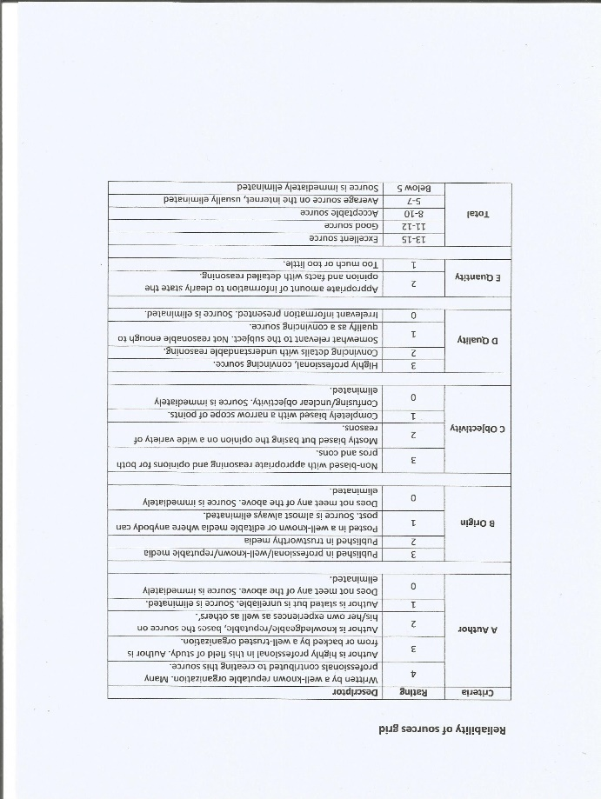From the evaluation done of the five sources, I have drawn conclusions on the research done. Regarding Arduino related research, I have discovered its ease of use from the company website, the book and taken Emad’s suggestion on it as he uses it and is gaining popularity. The prices are relatively low and the microcontrollers can be practiced on easily, it happens to be easily found across the world, and is open source meaning the Arduino C programming language is free to operate with, relying on short and easy codes. The research on the circuits and motors will allow me to look into what can power the circuit, understand the volt which is the electrical potential energy divided by the charge, and understand the units for current. I can understand what to program to cause the motors to spin in opposite directions which affects steering. Changing the current direction reverses the motor’s spin, the motor can spin in different paths depending on the magnetic field containing the north and south poles. All this detail will need to combined and practiced with prior to completing the product.

**Note: The photo attached above is a reliability grid based on author, origin, objectivity, quality and quantity, as obtained from the school PP booklet.**

The ATL skills used: I have **thought critically** about where to apply the research in the product and how I can merge my findings. By evaluating the sources, I have used my **research skills** by deciding on the usefulness of each source, as well as the reliability through the grid. I’ve used **self-management skills** in order to reflect upon the importance of every source and organized them by topics and thought about where the research would be most needed, and how to apply it.

**Journal Entry #6 Appendix D**

**Date: 24/5/2016**

**Type: Planning-The Action Plan.**

While working the research and its evaluation, I have also been working on the action plan, while also meeting with my supervisor, Ms. Zena. During the past meetings, she has informed me about the suitable ways of conducting the research necessary and finalizing the goal and product, in which we agreed it would be possible, although challenging. The other meeting was regarding the planning stage, in which we she has taught me the elements included in the action plan, which needs to include the investigating stage with the five sources that have been completely evaluated. The planning including the action plan, the timeline to go along with the action plan, and the success criteria, which is needed as the specifications for my product will be needed to measure its success, and in the reflecting stage. Also, I have decide that my designs will be in the planning stage, with three design ideas and a final design to work with and stick with, incorporating the success criteria into them to plan ahead; designs will also help develop my existing 3D drawing skills, Finally the planning stage includes a materials list to follow to create a neat product. The taking action stage involves doing the “heavy duty” work where I will be creating the product, relying on the research and planning done to follow the tasks I have allocated to myself. I will begin by purchasing the parts needed based on a budget I will allocate myself as part of the success criteria. Then practicing with Arduino C to gain enough skill prior to programming the car itself. The external parts depending on the final design will be bought and assembled, studied to understand where the circuit and other additional modifications will be placed. The car will then be programmed, and re-programmed until all the code is correct and is controlled through a smart phone. Finally, the external upgrades (solar panel) for example will be added and retested again. The reflecting stage is entered, and the product will be tested against the success criteria, seeing if the goal has achieved, contemplating on what is learnt, strengths and weaknesses and looking at the understanding of the topic. Note: I will merge the timeline and action plan together.

Challenges faced: Time-management is a current issue I face; the work done needs to be done over the summer to avoid procrastination and leaving work all piled up which will lead to stress. The timeline needs to be done carefully, finding the right time to work, and the number of times to work in a week.

**ATL skills:** I have done lots of critical thinking, and thought cautiously about the right course of action that needs to be done, all to ensure I create a high quality product, develop my skills through designs, and think of strategies that would keep me on the right course and sticking to the plan. My work with my supervisor required me to use social skills to discuss the right course of action to seek advice from my supervisor about the action plan. Finally, I have organized the order of the tasks based on where it belongs in the IPARD cycle, and why some steps need to be done before others. I heavily relied on self-management skills, as breaking these steps into large chunks of work provide a clearer sense of direction as to how the work should be completed.

Action to be taken: Work on timeline. Follow up questions: How can I ensure the best time management?

|  |  |  |  |
| --- | --- | --- | --- |
| Appendix E  Journal Entry #8 Date: 27/5/2016 Type: Planning- The Action Plan and Timeline | | | |
| Section | Action to be done | Time/ date (completed by) | Note that the process journals will be updated when a stage has been completed  The Investigating stage needed to be worked through quickly in order to provide time for studying Final Assessments on time  No course of Action in June, used for recreation. Work is continued on july, journals updated every Friday, work finished off in August, work is 1-3 days a week, finishing large chunks.  29/9/2016 is a Thursday, which is an exception made to meet the deadline |
| Investigating  (Research) | **Brainstorming ideas** | **9/2/2016** |
| **Deciding on a goal and a product**   * **SMART goals** * **Speaking to Mr. James for advice** * **Speaking to supervisor, Ms. Zena for feedback and discussing progress** * **Continue brainstorming and finalize goal** | **To be completed by 15/5/2016 in order to begin research early** |
| **Interviewing an expert - Emad Al Omari**  **Appointment booked and questions formulated** | **17/5/2016** |
| **Finalize and evaluate research, both primary and secondary** | **21/5/2016 to evaluate**  **23/5/2016 to draw conclusions.** |
| Planning | **The day where the action plan and timeline is made** | **27/5/2016** |
| **Formulate Success Criteria** | **30/5/2016** |
| **Complete design ideas, final design, and develop parts list** | **31/5/2016** |
| Taking Action (Building the Product) | **Purchasing parts & practicing how to program** | **8/7/2016** |
| **Finding the right code, and building the car** | **22/7/2016** |
| **Programming the vehicle** | **29/7/2016, occurs through trial and error+ many attempts** |
| **Applying exterior features+ fixes if needed** | **12/8/2016** |
| **Make improvements, in order to move to reflecting.** | **19/8/2016.** |
| Reflecting | **Evaluating product and work against success criteria** | **2/9/2016, a lot of time is needed for recording and testing** |
| **Reflecting on knowledge about topic** | **9/9/2016** |
| **Reflecting on understanding of Global context of Scientific and technical innovation** | **16/9/2016** |
| **Reflecting on growth as an IB learner** | **23/9/2016** |
| **Strengths and Weaknesses of project** | **29/9/2016** |

**Appendix F**

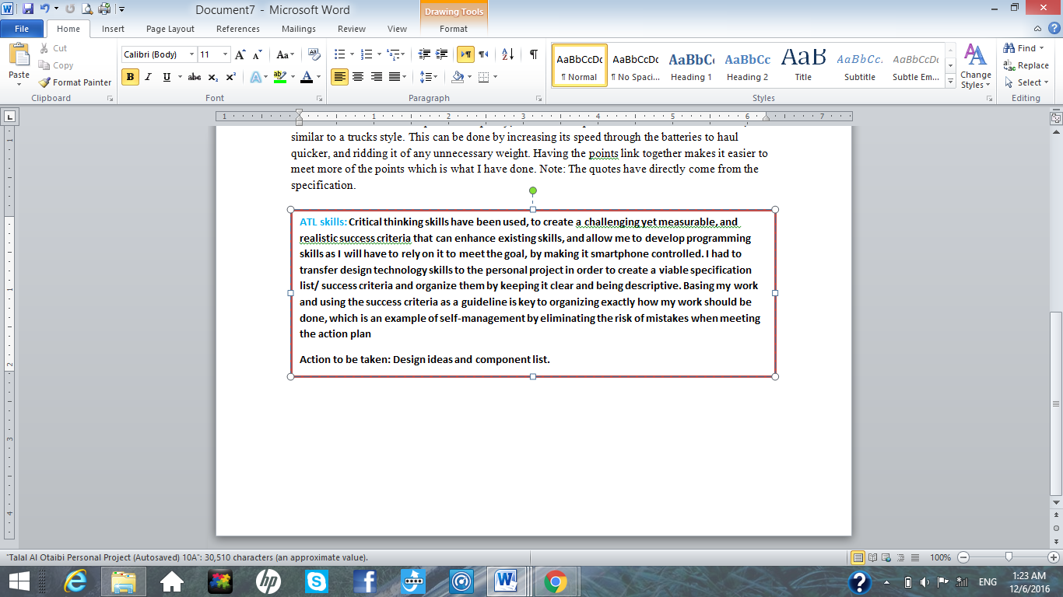**Journal Entry #9**

**Date: 30/5/2016**

**Type: Planning- Success Criteria. 1.** The first success criterion states that the dimensions of the vehicle should be no longer than 400mm from the back to the front and 250mm wide. It should also be no higher than 250mm. These specific dimensions are chosen as they limit the usage of large and bulky material, as well as avoid high mass which makes the vehicle slow. The relatively scaled down dimensions make it challenging, since a lot of detail needs to be integrated into a vehicle system small enough.

1. The vehicle should be no more than 5kg. Low mass is needed to remain maneuverable and lightweight. This is a challenge that relies on decision making skills for proper material choice and usage, which can enhance design skills.
2. The vehicle must be agile, which can be accomplished by making it lightweight. It needs to be capable of 360° motion in that it moves in all directions. This can be tested through controlling the vehicle to turn around in a circular manner while stationary and moving. This pushes the challenge to the maximum, where research regarding the current flow and motors will be incorporated. This is tested by operating the vehicle in the local urban streets at an inclination of no more than 30° upwards.
3. The power needed to drive the vehicle is a key point. Therefore, the power is applied to 2 permanent D.C motors, resulting in an output shaft torque. This means that every 1 cm of the shaft length can move a 10kg load. This enables the steering of the vehicle, which is simpler as the system relies on one track having more power to influence the steering. It is a challenge as the motors need to be programmed individually, therefore enabling a development of programming skills.
4. The next criterion is speed. It needs to be a minimum of 1 km/hr. As 2 permanent magnet motors will be used, there is an inverse relationship between torque and speed (LearnEngineering). The speed decreases, as increasing the torque comes from increasing the distance, where Torque= force x distance. The increased torque comes from larger gears with larger radii, which comes at a cost of the revolution of the gear taking more time. This reduces the spin speed for quicker movements. This relies on incorporating the system neatly, and enhances physics knowledge that is needed to improve my making and design skills when it comes to power output.
5. The budget allocated is no more than 250 Jordanian Dinars. I am funding it myself. The money is to be spent on all items that came out of the research. This includes the male-male wires, H bridge amplifier, and Bluetooth module.
6. The product needs to be environmentally friendly. I can recycle existing plastics and materials available at home, and use an electrical system and solar panel to avoid greenhouse gas emissions. The challenge comes by allowing the vehicle to be entirely smartphone controlled, which leads to increased difficulty and dependence on critical thinking and research, through implementing the programming and Bluetooth into the steering. This is tested by ensuring the circuit works reliably.
7. A point that addresses the entirety of my project understands what I’ve researched and have successfully applied it. Meeting this point ties this project to scientific and technical innovation as I have adapted my thinking and built on my knowledge through extended scientific research.

**Journal Entry #11 Appendix G**

**Date: 31/5/2016**

**Type: Planning- Final Design, Part list, moving to taking action stage.**

The same day I have created the design ideas, is the same I made the final design, decided on needed parts, and made a final meeting with my supervisor for the year. The final design is heavily based on the third design idea. But I have borrowed elements from the first and second. I have decided to use the buzzer and simplicity of the first idea, and the solar panel from the second in order to make a simple car loaded with useful features. The final design has been drawn with more detail and has dimensions. The chassis, is derived from the rover 5 kit, to use its treads and place the storage as an external body. The measurements for the kit is around 245mm long, 60mm high, and 225mm wide. The top will likely be a plastic toolbox, as plastic can be punctured and modified easily, or might be any other form of storage resembling the high capacity of the design.

The meeting with my supervisor is to confirm the progress of my work, and continue working on the project in the summer. Showing her work, and asking Ms. Zena for advice on success criteria, and action plan helped me tremendously as I can present it in a much more organized fashion.

The parts needed were heavily based of Emad’s answers from the interview.

Essential Parts: (Parts list)

1. Arduino Mega board with microcontroller
2. Female-male wires
3. Male-male wires
4. Bluetooth module
5. Drive circuit (H bridge) to amplify volts from Arduino to power motors or else the circuit can burn
6. Rover 5 kit
7. Battery (more than one if possible)
8. Adapter for charging the battery.
9. Body.
10. Selfie stick to be remade into platform to hold solar charger.

Desirable parts are parts such as a buzzer acting like a horn, breadboard for practicing, LED’s, a switch, and a solar charger.

ATL skills used: By talking to Ms. Zena, and discussing progress with her (approval to taking action), my reliance on **social and collaboration skills** have increased, as my supervisor is an excellent method of correcting mistakes I have not noticed. Communication is key; I have made **critical and creative thinking** for my design to incorporate elements that were useful form other ideas and merged them. I transferred my skills from Design Technology to apply it here for a higher standard of quality for my project.

**Journal Entry #14 Appendix H**

**Date: 29/7/2016**

**Type: Taking Action- Programming the car**

With the car and its main body being produced, I needed to program the car now, I have downloaded the app as it is free, accessible, and allows for easier programming to control the car through the Bluetooth module, within the app made for Arduino, there is a settings option showing what letter each function should be so it acted as a basis for the programming. 7 pins were made to, two to control motor speed, 4 for the current and circuit, and one for the buzzer. I established serial communications by programming the Bluetooth, and having the analyses information stored under x, with all functions underneath being a set of the character x. The Bluetooth module is a transmitter and receives information at the same time, as well as the Arduino board receiving then re-transmitting, which created the feedback loop.

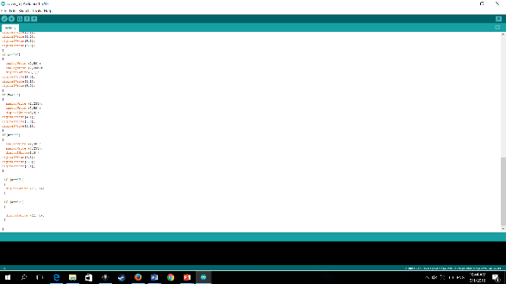The steering involves which side or motor has more power than the other, rather than using a suspension and servos. With the programming complete, it was necessary to now establish the circuit, the code has been uploaded to the board with no syntax or technical errors. The battery was attached to the Arduino, with the pin wires (male-male) attached and leading to the H-bridge to amplify the volts, which then reaches the motors. The Bluetooth module is attached to the Arduino with male-female wires. A switch was added in between the wire from the battery to the Arduino board, allowing it to be turned on and off. The buzzer was placed in pin 11, with the other prong being attached to the ground. It is necessary that there is a difference in the volts whether a positive amount of volts and about 0 zero at the other.

Challenges: organizing the wires, is tough, some have been tied together with zip locks as a solution, they have been fastened. Another problem is keeping the circuit sturdy, which needed lots of duct tape to attach parts like the drive circuit and module to the walls of the care.

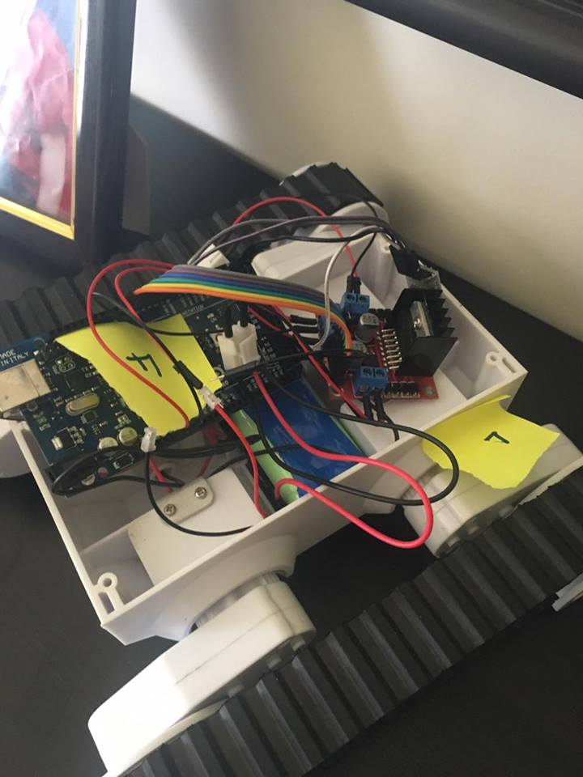ATL skills: As the circuit is hard to program, I needed to a bit of consulting to Emad for advice, thus I had to use **communication skills** with him to progress, and also **think critically** to solve problems, such as the car not stopping when controlled which needed extra codes to place the motors at no speed when inactive rather than creating a letter dedicated to stopping the car. As I wanted to chunks of work done over larger periods of time, two weeks of July were used for work rather than doing smaller chunks, allowing to get more work done with overall, acting as a strategy for **self management** to get back on track.

Action to be taken: apply solar charger, look for improvements.

The photo represents the wiring prior to adding the body, with stickers to indicate direction.

**Journal Entry #16 Appendix I**

**Date: 19/8/2016**

**Type: Taking Action- Improving the car, moving on to reflecting stage.**

I have consulted Emad Al Omari once more in fixing the main problem, which is the low speed. He has thus lended me a voltmeter on the 18th of August to test if the battery is completely dead after recharging it. It turns out that the 7.3 volt battery was intact, but the only way to create a more consistent vehicle that can travel at a constant speed, was to have a battery with higher volts. Therefore, I have bought another 7.3 volt battery creating a total of 14.6 volts. I used more wires to connect it to the circuit, therefore making it much faster, even twice the speed or more. The car has become much faster, and maneuverable overall, and carry loads at higher speeds.

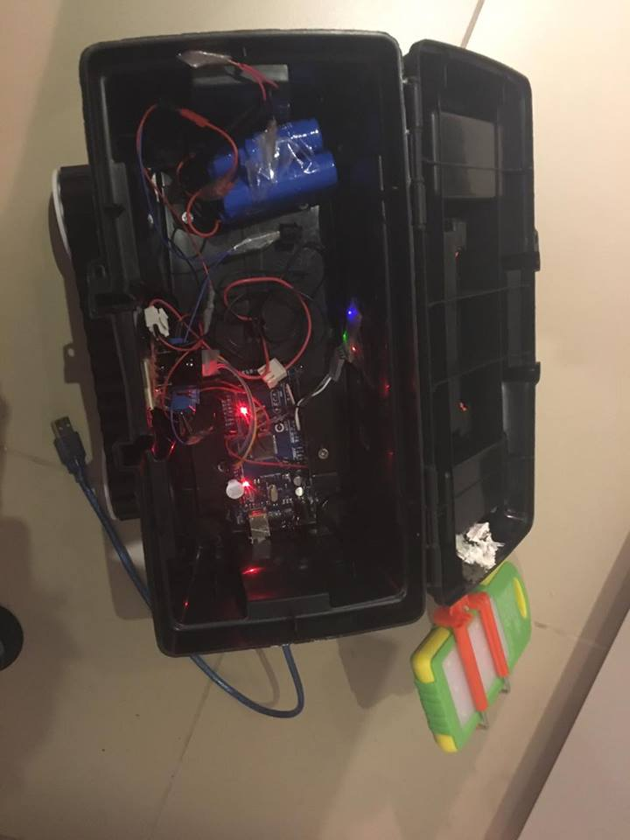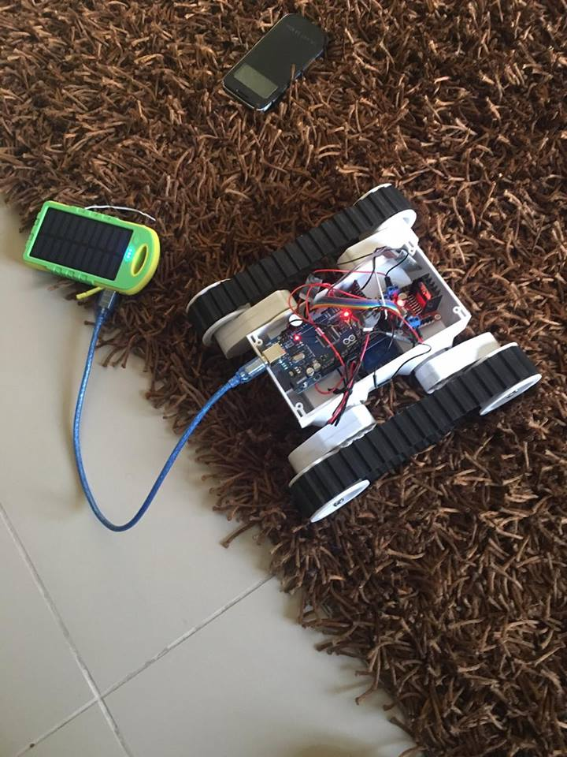To tighten the solar charger, I have also taken the car to Emad’s office to use an electronic silicone gun to tighten and lock the selfie stick pole into the main body of the car. The holes are fixed by carefully cutting them out even more into rectangular and circular slots to improve on the visuals/ aesthetics of the car itself. The silicone gun allows for neat and smooth adhesion of the selfie stick improving on the total reliability of the car, by not worrying about it falling or wobbling when the car is moving.

Now that the car is complete, I can move on to the reflection stage where I can use the success criteria to evaluate the car, see if the goal has been achieved through the product, investigate my growth and development of my technical skills, and growth as an IB learner, and check if my understanding of the topic has been met.

**ATL Skills: Through my work with Emad, I have extensively depended on social skills and collaboration skills to seek advice with him, and take advantage of the wide array of tools and equipment he has offered. As a specialist, his engineering skills and his resourcefulness has come in handy for many of the stages. I have also relied on my research as a reference for critical thinking, where I used the concept of the batteries and functions as a technical solution to the largest flaw of the vehicle, its low mobility.**

**Action to be taken: Proceed with reflecting stage, and take final measurements before evaluation against the success criteria. (Photos of the car on a separate document).**

2 photos showing the differences between the circuit in the car without the body, and within the body.

**Journal Entry #17 Appendix J**

**Date: 2/9/ 2016**

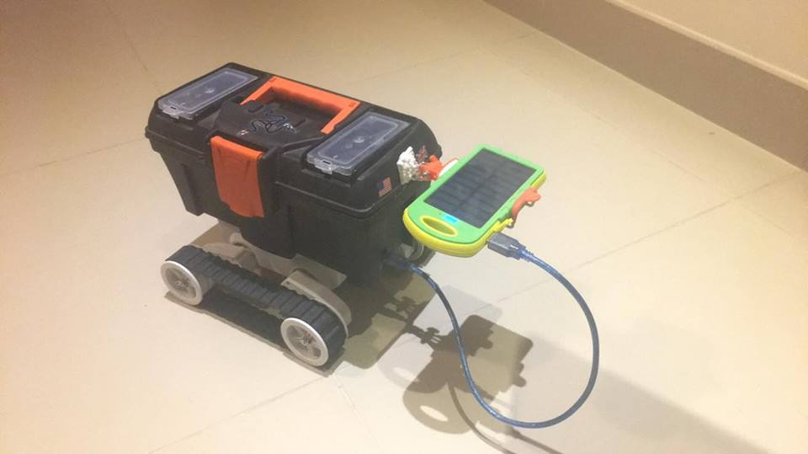**Type: Reflecting- Evaluating final product against Success criteria**

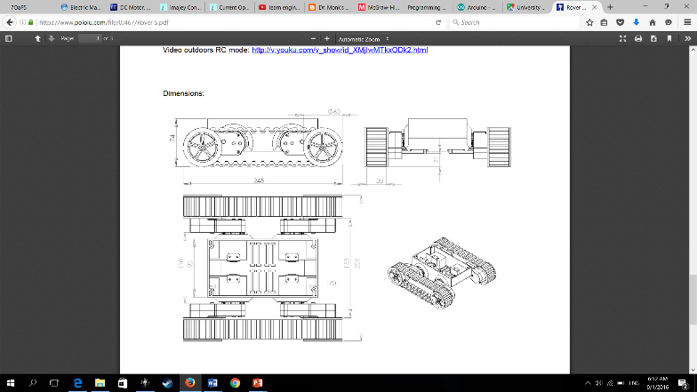

The photo on the left shows the final product. The renderings on the right show the rover 5 kit it was based on + dimensions

Pololu. "Rover 5." *Pololu*. Pololu, n.d. Web. 12 Sept. 2016.

|  |  |
| --- | --- |
| Success criterion | Met or not |
| Dimensions no longer than 400mm from the back to the front and 250mm wide. It should also be no higher than 250mm | Yes (all dimensions match exactly). The maximum length is 410mm because of the panel, but this is negligible. Measured using measuring tape |
| Mass no more than 5kg | Yes the final mass of the vehicle is 2.6kg, this is due to the lightweight plastic of the body and small circuit size (measured with mass balance) |
| Agility and 360 degree motion | Yes, it completely turns at a 360 degree angle, drives at a wooden board measured 30° upwards, and drives steadily on local Amman streets |
| Motor power | Yes, 2 motors programmed, 10kg/cm output shaft torque motors selected that are permanent magnet D.C. Responsive steering |
| Speed | Yes 2.3km/h. 10 meter distance for vehicle to cross, time is measured. Speed is above double, caused by using 2 batteries with double recommended voltage of 7.2V |
| Budget | Yes 143.5 JD on parts of part list, meaning 57.4% of budget spent |
| Environmental friendliness | Yes. Solar panel and purely electric system with switch. |
| Research understood and applied | Yes, all research has been synthesized to formulate new creative ideas |

ATL skills: **Reflection skills** were needed to evaluate the products success, in all aspects. **Thinking skills** were needed for appropriate measurements and justification to results**. Organization self-management skills** are needed to portray the information neatly, and communication as Mr. Yaaseen has given feedback on methods of testing.